R-2 Capsule Launcher
Assembly and maintenance instructions
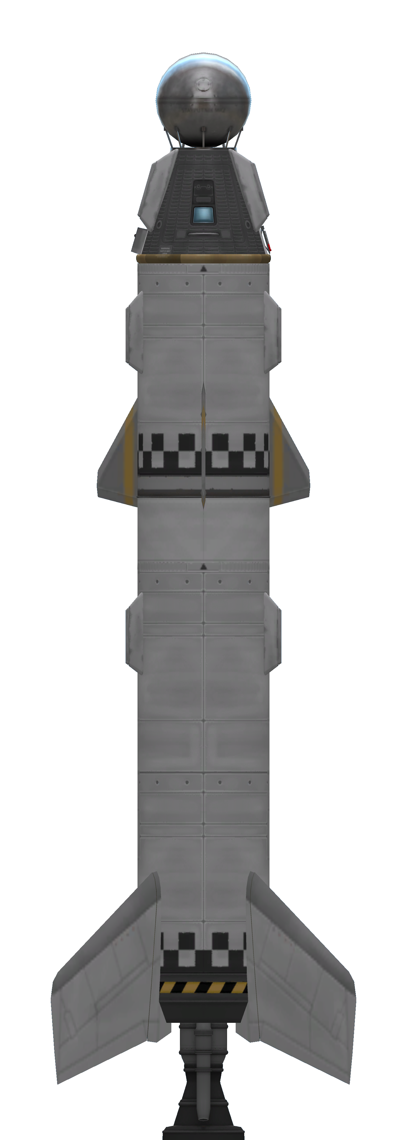
Table of Contents
Description 3
Basic construction 3
Assembly instructions 3
Parts list 3
Technology 3
Stacking 3
Stage configuration 6
Lower stage 6
Upper stage 6
Staging 6
Post flight maintenance 7
Pre rollout checks 7

Description
The R-2 is a dumb, multi-stage, recoverable, liquid fuelled booster for launching naked capsules based on the Mk-1 pod.
The rocket is composed of pre-assembled stages and is relatively simple to construct once these assemblies are ready.
No computer is provided. The R-2 takes its commands from the payload. The lower stage provides control via movable fins. The upper stage engine is gimballed.
The whole system is recoverable, with the exception of the upper stage fins which must be replaced after every orbital flight.

Basic construction
The rocker is built in a single assembly operation and construction is straightforward. There is only a single model of the R-2 rocket, comprised of the RS-1A booster and the SM-1 upper stage.
The launcher is designed for launching AOC-0 and AOC-1 capsules. The R-2 provides launching with enough delta V for deorbiting and minimal to no maneuvering (from at least 100 m/s for a polar orbit to at least 300 m/s for an equatorial one).

Assembly instructions

Parts list
1x RS-1 lower stage
1x SM-1 upper stage

Technology
The rocket requires a level 4 technology level. Both stages require this technology level.

Stacking
Stack SM-1 over RS-1. Connect SM-1 engine to RS-1 decoupler. Capsule should be attached to upper stage decoupler.
When stacking, the following rules apply.
- Shroud MUST be enabled
- Parachutes MUST all have the same orientation (N/S by default)
- RS-1 gas generator MUST should point in the same direction as one of the upper stage fins
  - This is the “up” direction
- Lower stage fins MUST be oriented forming an X when compared with up/down and side directions
  - They MUST NOT point in the up/down/left/right directions
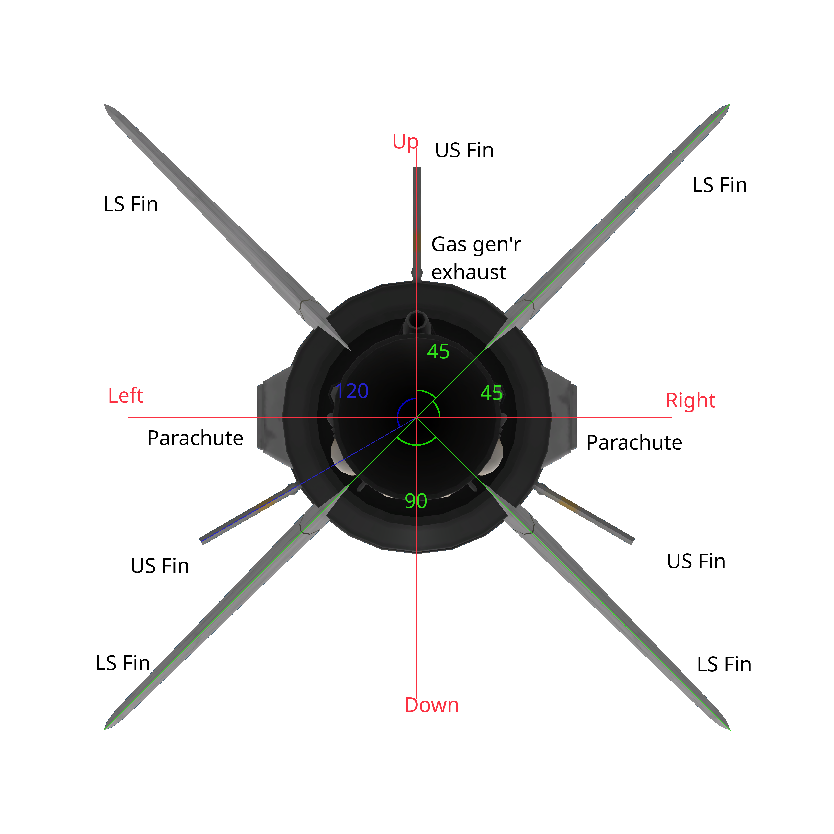Figure 1: Relative positions of parts in stacked launch vehicle as viewed from the nozzle

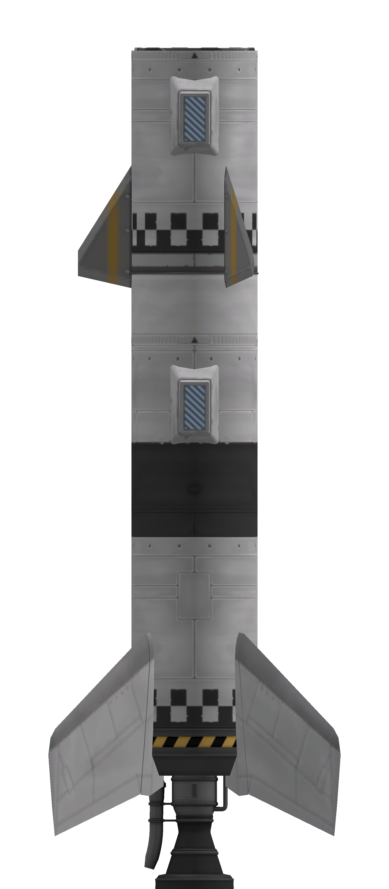Figure 2: R-2 800 final stacked form side view

Stage configuration
Configuration is derived from stage configuration. Tables below are copied from their respective manuals.

Lower stage
Part | Variable | Value | Default | Notes
Fins | Pitch | Active | Yes
Fins | Yaw | Active | Yes
Fins | Roll | Active | Yes
Fins | Deploy | Retracted | Yes
Fins | Deploy direction | Normal | Yes
Fins | Deploy angle | 0 | No
Fins | Authority limiter | 4 | No
Engine | Throttle | Main throttle | Yes
Engine | Thrust limiter | 100 | Yes
LFOX tank 1 | Flow priority | 0 | Yes | Uppermost tank
LFOX tank 2 | Flow priority | +1 | No
LFOX tank 3 | Flow priority | +2 | No | If present
LFOX tank 4 | Flow priority | +3 | No | This tank is not used in the R-2
Decoupler | Force percent | 100 | Yes
Decoupler | Enable crossfeed | False | Yes
Decoupler | Enable staging | True | Yes
Parachutes | Deploy mode | When safe | Yes
Parachutes | Min pressure | 0.45 | No
Parachutes | Altitude | 500 | No
Parachutes | Spread angle | 10 | No

Upper stage
Part | Variable | Value | Default | Notes
Engine | Thrust limiter | 100 | Yes
 | Throttle | Main throttle | Yes
LFOX tank | Flow Priority | 0 | Yes
Decoupler | Force percent | 100 | Yes
 | Enable crossfeed | False | Yes
 | Enable staging | True | Yes
Parachutes | Deploy mode | When safe | Yes
 | Min pressure | 0.45 | No
 | Altitude | 500 | No
 | Spread angle | 10 | No

Staging
Stage | Parts | Notes
0 | US Parachutes, US Decoupler
1 | US Engine, LS Parachutes, LS decoupler
2 | LS Engine

Post flight maintenance
When stacking after a flight, the following abbreviated maintenance procedure can be executed. If in doubt, execute full stacking procedure.
- RS-1 Decoupler
  - Enable staging
- SM-1 Decoupler
  - Enable staging
- Tanks
  - Fill

Pre rollout checks
- Verify staging
- Verify parachute settings
- Verify decoupler staging
- Verify payload is present

